JOSEPH M. MARRONE
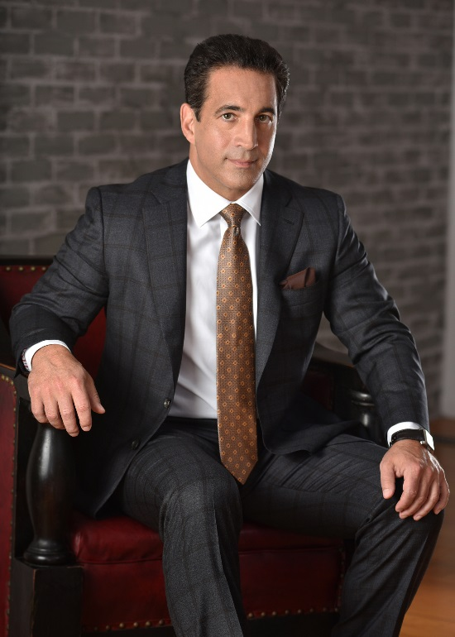

Location: Philadelphia, Pennsylvania
Phone: 215-732-6700
Fax: 215-732-7660
Email: jmarrone@marronelawfirm.com
Website: www.marronelawfirm.com

Joseph graduated from law school in 1991, moving on to earn bar admissions in New Jersey (1991), Pennsylvania (1992), and New York (2004). He is also licensed to practice in the U.S. District Courts of the aforementioned states, the 3rd Circuit Court of Appeals, and the United States Supreme Court. After graduating law school, Joseph worked as a political advisor to former Governor of Pennsylvania, Edward Rendell for his mayoral campaign in Philadelphia. Shortly thereafter, he was appointed Assistant City Solicitor in the Rendell administration and spent countless hours representing the City of Philadelphia.

Over the past two decades, Joseph Marrone has consistently represented clients both on a local and national level in a variety of legal matters. Marrone Law Firm, LLC has developed into a high-end, high-powered litigation firm that focuses on catastrophic injury and wrongful death cases. Joseph has extensive experience and has achieved impressive results trying cases involving personal injury, products and premises liability, medical malpractice and motor vehicle accident matters. Additionally, Joseph has a long standing career as a criminal defense attorney winning many notable verdicts. His legal acumen also extends to representing many prominent clients in the music and film industries.
During his professional career, Joseph has taken on a number of high-profile cases resulting in multi-million dollar verdicts or settlements. Some of Joseph’s most noteworthy settlements include, but are not limited to a $227 million dollar unprecedented settlement for a building collapse case in Philadelphia, a $17 million dollar settlement for a medical malpractice lawsuit when a man was admitted to a local hospital for an elective heart procedure which left him permanently incapacitated, a $4 million dollar settlement for the estate of a woman that died as a result of hospital malpractice, a $2.9 million dollar settlement for a man who drowned in a New York resort, a $2 million dollar settlement for the estate of a New Jersey State Trooper killed in car accident and a $2 million dollar settlement against a major casino corporation on behalf of a noteworthy entertainer involved in a limo accident. To review a complete list of Joseph’s verdicts and settlements, visit the Results page on the firm’s website at www.marronelawfirm.com.

In addition to Joseph serving as legal counsel in the entertainment industry, he is also an entrepreneur and executive. He founded Antra Entertainment, a recording and publishing company brokering joint ventures with various companies such as A&M, Sony, Polygram and Universal Music Group. The company had numerous platinum albums and soundtracks. The successes of Antra extended into the T.V. and film industry, working with numerous companies such as HBO, Miramax, Lionsgate, Amazon and Netflix.
As a producer and manager, he has worked with Laurence Fishburne, Dr. Dre, Snoop Dogg, Wesley Snipes, Sean “Puffy” Combs, Spike Lee, Shaquille O’Neill, Barry Michael Cooper amongst many others. Joe continues to consult and produce in the T.V., film and music industries.

In addition to achieving impressive results for his clients, Joseph was selected as an “Awesome Attorney’” in South Jersey Magazine by reader’s choice in 2014, 2016 & 2017; and as a 2014 “Top Attorney” in Philadelphia Life/Suburban Life Magazine. Joseph was also honored by U.S. News and World Report in the category of “Best Law Firms” for the areas of Plaintiff - Personal Injury Litigation (2016 & 2017) and Plaintiff - Medical Malpractice Law (2016, 2017, 2018 & 2019). In both 2016 & 2017, The American Institute of Personal Injury Attorneys recognized his achievements by awarding him the prestigious “10 Best” Personal Injury Attorneys for Client Satisfaction in Pennsylvania. Also in 2017, Joseph Marrone was invited for membership to the prestigious “Million Dollar Advocates Forum” in recognition of achieving multiple settlements in excess of a million dollars or more for his clients. Membership to this elite group consists of less than 1% of attorneys in the United States.

In recognition of Joseph Marrone’s efforts in the area of community outreach, he was selected in 2017 to become a member of the Governing Board of Directors for Big Brothers Big Sisters of Philadelphia – Independence Region. This organization is a one–to-one, non-profit, mentoring organization which is making significant impact on youth in need, nationally.

Due to his impressive level of achievement and the incredible amount of respect gained among his peers during his tenure in the legal field, Joseph has appeared numerous times on NBC and FOX as a legal analyst both locally and nationally.
In addition to television, Joseph has been invited to speak on multiple radio shows including becoming a regular legal contributor on the nationally syndicated, iHeart Radio show, “This Morning – America’s First News with Gordon Deal”, speaking on a variety of legal topics making today’s headlines.

Bar Admissions
- New Jersey, 1991
- Pennsylvania, 1992
- New York, 2004
- Supreme Court of the United States of America, 1996

Acknowledgements

- "Best Law Firms" by U.S. News & World Report – Best Lawyers® in 2018.
Joseph Marrone was selected for the area and Medical Malpractice Law.

- "Best Law Firms" by U.S. News & World Report – Best Lawyers® in 2017.
Joseph Marrone was selected for the areas of Plaintiffs Personal Injury Litigation and Medical Malpractice Law.

- "10 Best" Personal Injury Law Attorneys for Client Satisfaction in Pennsylvania - 2017.
This prestigious award is an honor given by the American Institute of Personal Injury Attorneys

- "Best Law Firms" by U.S. News & World Report – Best Lawyers® in 2016.
Joseph Marrone was selected for the areas of Plaintiffs Personal Injury Litigation and Medical Malpractice Law.

- "10 Best" Personal Injury Law Attorneys for Client Satisfaction in Pennsylvania - 2016.
This prestigious award is an honor given by the American Institute of Personal Injury Attorneys
- 2016 edition of The Best Lawyers in America for Plaintiffs Personal Injury Litigation
- ‘Awesome Attorney’ 2016 – Personal Injury in South Jersey Magazine by reader’s choice
- ‘Top Attorney’ 2015 in Philadelphia Life/Suburban Life Magazine
- ‘Awesome Attorney’ 2014 – Personal Injury in South Jersey Magazine by reader’s choice
- ‘Top Attorney’ 2014 in Philadelphia Life/Suburban Life Magazine

ASSOCIATIONS
  - New York Bar State Bar Association
  - Pennsylvania Bar Association
  - New Jersey Bar Association
  - American Bar Association
  - American Justice Association
  - Philadelphia Trial Lawyers Association
  - New Jersey Association for Justice
  - Million Dollar Advocates Forum

